Figures
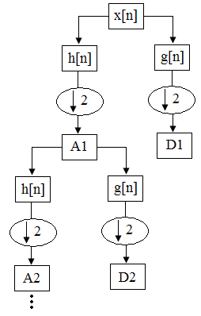
Figure 1. Schematic representation of Multi-Resolution Analysis (MRA)

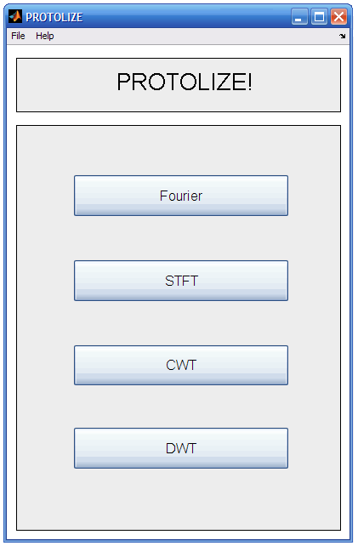
Figure 2. Main panel of Protolize! with buttons to access each analysis module.

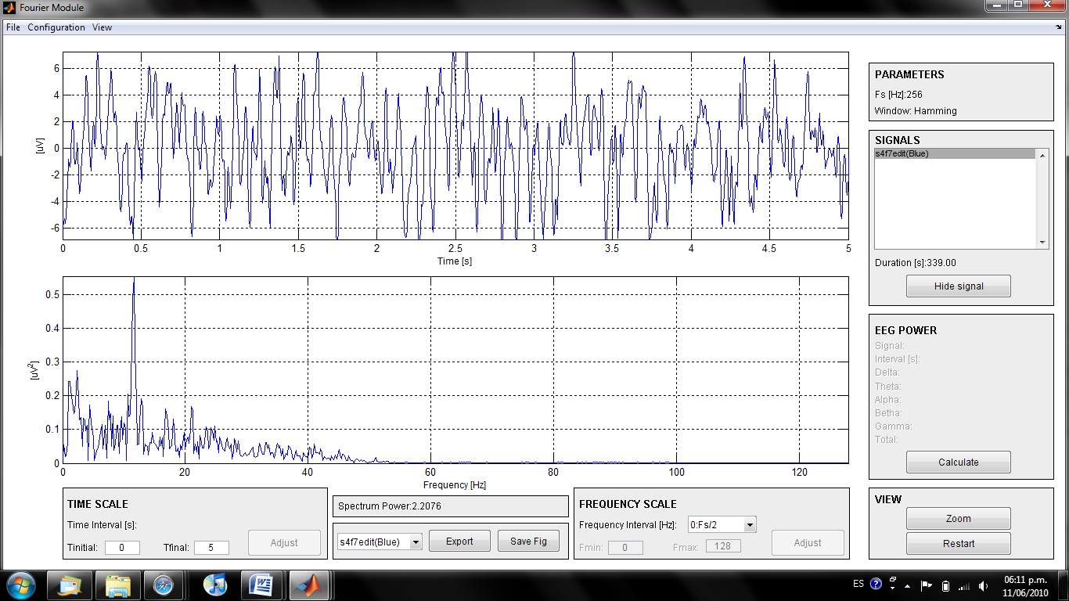
Figure 3. Fourier Module showing an EEG signal processed.

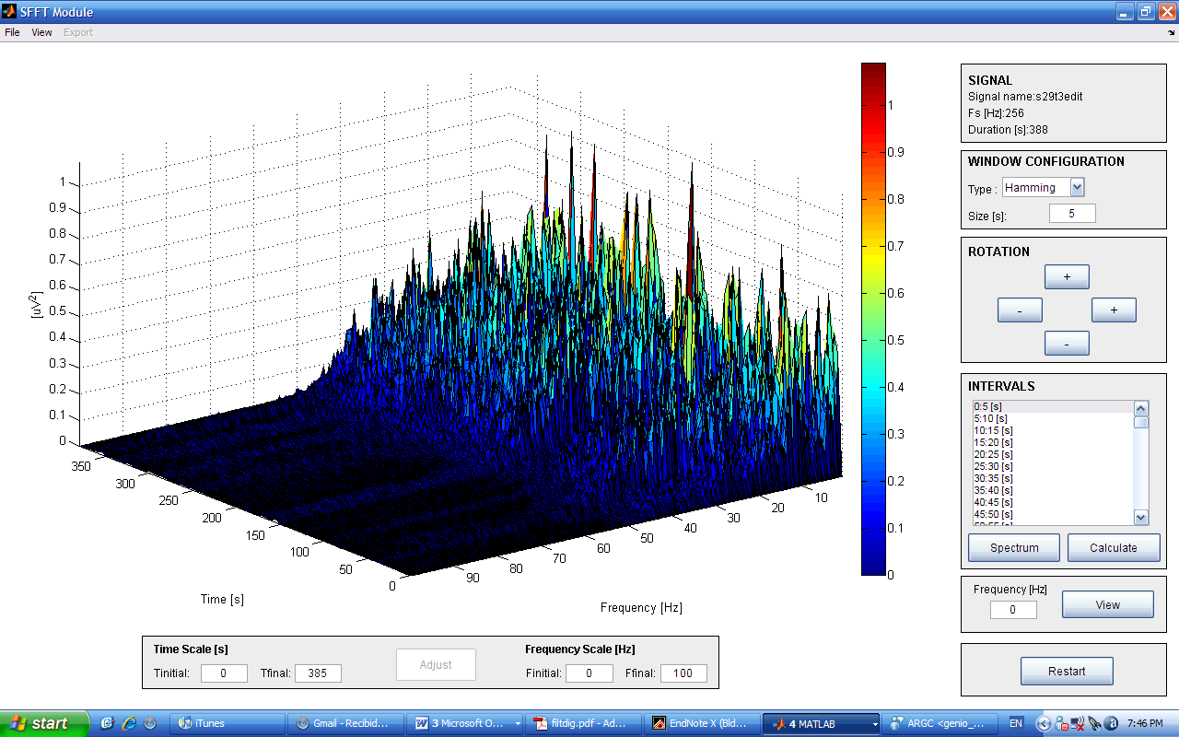
Figure 4. STFT Module showing an EEG signal processed.

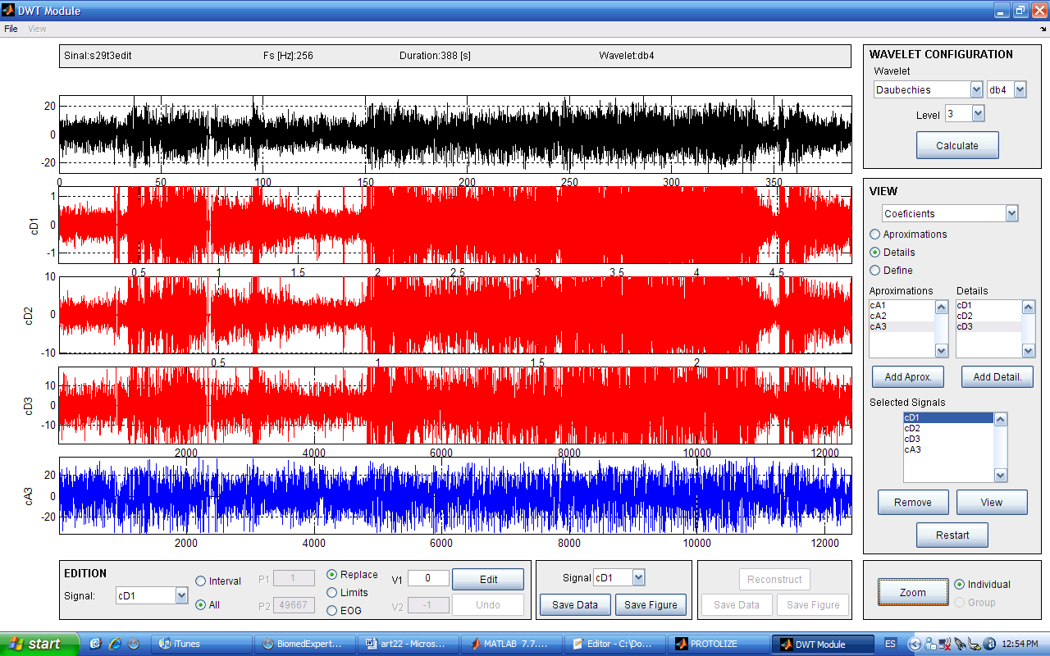
Figure 5. DWT Module showing a three level multi-resolution analysis using a db4 wavelet

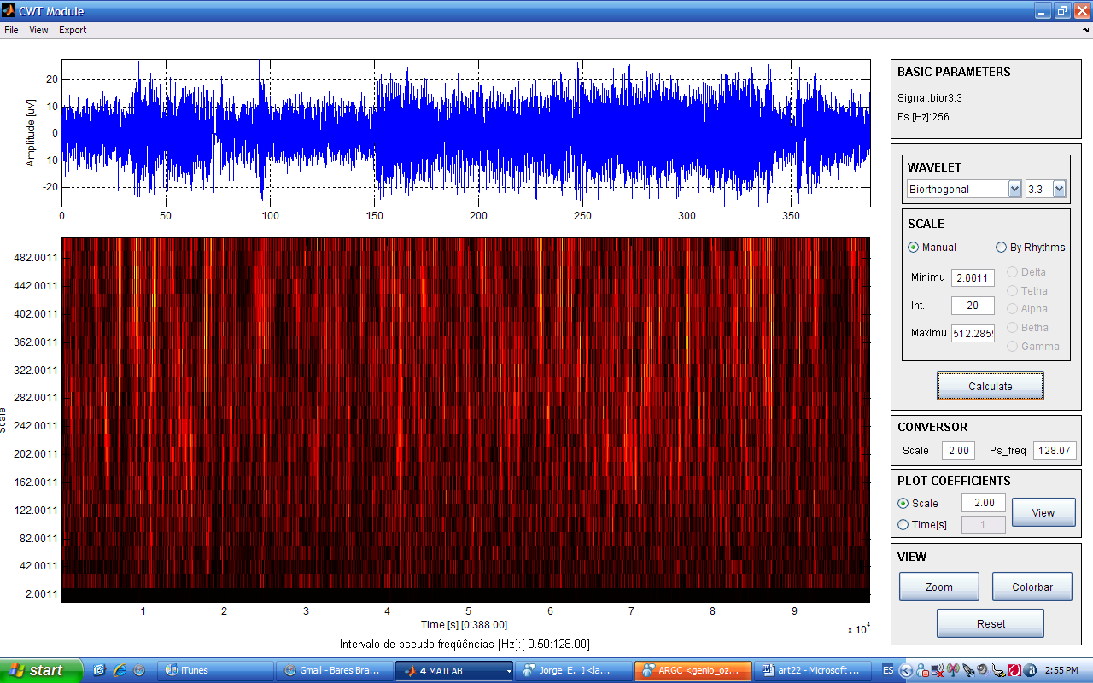
Figure 6. CWT Module showing an EEG signal processed with biorthogonal 3.3 wavelet between scales 2 and 512 in 20 scale intervals.

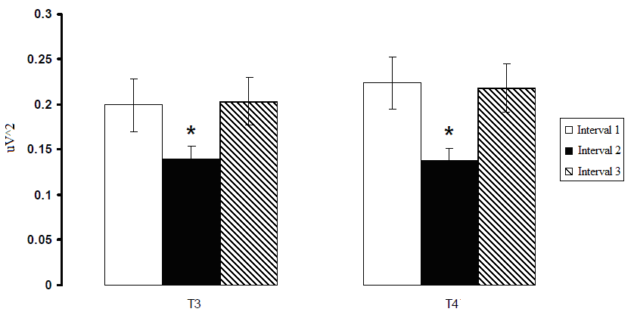
Figure 7. Mean +/- SE of alpha power in each interval. * Differences statistically significantly between interval 2 (opened eyes) and intervals 1 and 3 (closed eyes)

